Java array->

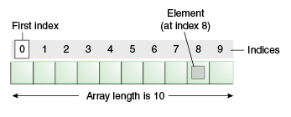

Advantage of Java Array

* **Code Optimization:** It makes the code optimized, we can retrieve or sort the data easily.
* **Random access:** We can get any data located at any index position.

Disadvantage of Java Array

* **Size Limit:** We can store only fixed size of elements in the array. It doesn't grow its size at runtime. To solve this problem, collection framework is used in java.

Types of Array in java

There are two types of array.

* Single Dimensional Array
* Multidimensional Array

[**next →**](http://www.javatpoint.com/wrapper-class-in-java)[**← prev**](http://www.javatpoint.com/object-cloning)

# **Java Array**

Normally, array is a collection of similar type of elements that have contiguous memory location.

**Java array** is an object the contains elements of similar data type. It is a data structure where we store similar elements. We can store only fixed set of elements in a java array.

Array in java is index based, first element of the array is stored at 0 index.

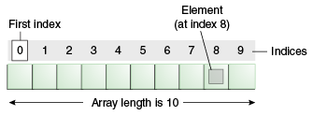

### Advantage of Java Array

* **Code Optimization:** It makes the code optimized, we can retrieve or sort the data easily.
* **Random access:** We can get any data located at any index position.

### Disadvantage of Java Array

* **Size Limit:** We can store only fixed size of elements in the array. It doesn't grow its size at runtime. To solve this problem, collection framework is used in java.

### Types of Array in java

There are two types of array.

* Single Dimensional Array
* Multidimensional Array

### Single Dimensional Array in java

### Syntax to Declare an Array in java

1. dataType[] arr; (or)
2. dataType []arr; (or)
3. dataType arr[];

Instantiation of an Array in java

1. arrayRef Var=**new** datatype[size];

int a[]=new int [10];

examp->

## **Declaration, Instantiation and Initialization of Java Array**

We can declare, instantiate and initialize the java array together by:

1. **int** a[]={33,3,4,5};//declaration, instantiation and initialization

PASSING an array as a argument->

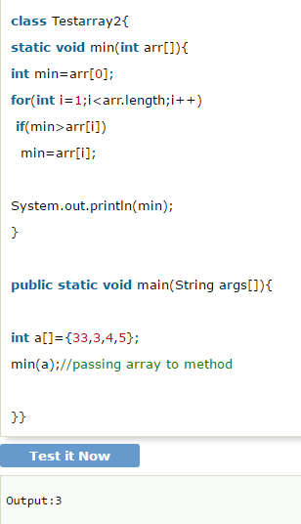

Multi dimensional array->

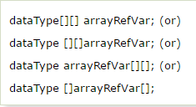

Example to instantiate Multidimensional Array in java

1. **int**[][] arr=**new** **int**[3][3];//3 row and 3 column

Example to initialize Multidimensional Array in java

1. arr[0][0]=1;
2. arr[0][1]=2;
3. arr[0][2]=3;
4. arr[1][0]=4;
5. arr[1][1]=5;
6. arr[1][2]=6;
7. arr[2][0]=7;
8. arr[2][1]=8;
9. arr[2][2]=9;

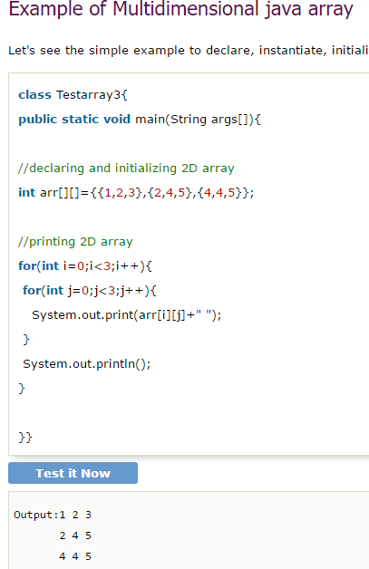

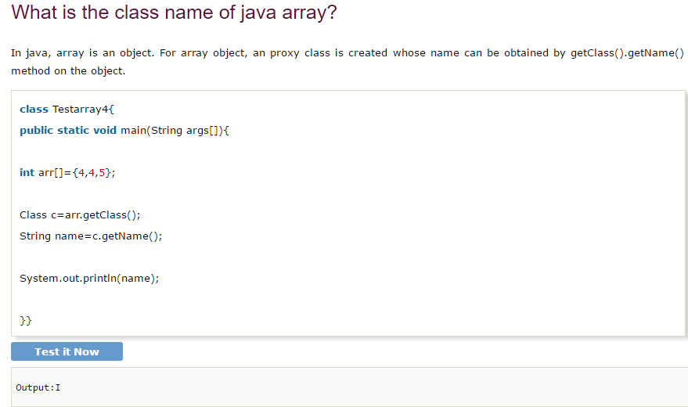

### Copying a java array->

### We can copy an array to another by the arraycopy method of System class.

Syntax of arraycopy method

**public** **static** **void** arraycopy(  Object src, **int** srcPos,Object dest, **int** destPos, **int** length  )

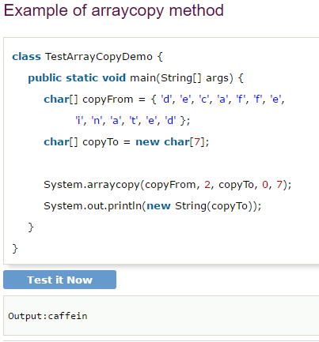

Addition of two matrix in java->

